Experiment No.7

Title: Data Warehouse simulation

Batch: B3 Roll No.: 16010422230 Experiment No.:7

Aim: To run Data Warehouse simulation

___________________________________________________________________________

Resources needed: Different RDBMS such as MySQL, Postgres
___________________________________________________________________________

Theory

Data Warehouse :
A data warehouse is a type of data management system that is designed to enable and support business intelligence (BI) activities, especially analytics. Data warehouses are solely intended to perform queries and analysis and often contain large amounts of historical data. The data within a data warehouse is usually derived from a wide range of sources such as application log files and transaction applications.
A data warehouse centralizes and consolidates large amounts of data from multiple sources. Its analytical capabilities allow organizations to derive valuable business insights from their data to improve decision-making. Over time, it builds a historical record that can be invaluable to data scientists and business analysts. Because of these capabilities, a data warehouse can be considered an organization’s “single source of truth.

ETL :
Extract, Transform, Load (ETL) refers to a process in database usage and especially in data warehousing. Data extraction is where data is extracted from homogeneous or heterogeneous data sources; data transformation where the data is transformed for storing in the proper format or structure for the purposes of querying and analysis; data loading where the data is loaded into the final target database, more specifically, an operational data store, data mart, or data warehouse.
By using an established ETL framework, one may increase one's chances of ending up with better connectivity and scalability. A good ETL tool must be able to communicate with the many different relational databases and read the various file formats used throughout an organization. ETL tools have started to migrate into Enterprise Application Integration, or even Enterprise Service Bus, systems that now cover much more than just the extraction, transformation, and loading of data. A common use case for ETL tools include converting CSV files to formats readable by relational databases. A typical translation of millions of records is facilitated by ETL tools that enable users to input csv-like data feeds/files and import it into a database with as little code as possible. ETL tools in most cases contain a GUI that helps users conveniently transform data, using a visual data mapper, as opposed to writing large programs to parse files and modify data types.

__________________________________________________________________________

Activities:

For Data Warehouse:
- Visit https://www.oracle.com/webfolder/s/assets/demo/adw-quicktour-na/index.html#step1
- Go through the demo of Autonomous Data Warehouse for different businesses
- Prepare a report with following points
  - The nature of analytics for different businesses given
  - Comparison between traditional analysis and analysis with Data Warehouse
  - For any two-business type given, specify at least two different scenarios where the tool can be useful

________________________________________________________________________
Results:

- Report for Data Warehouse

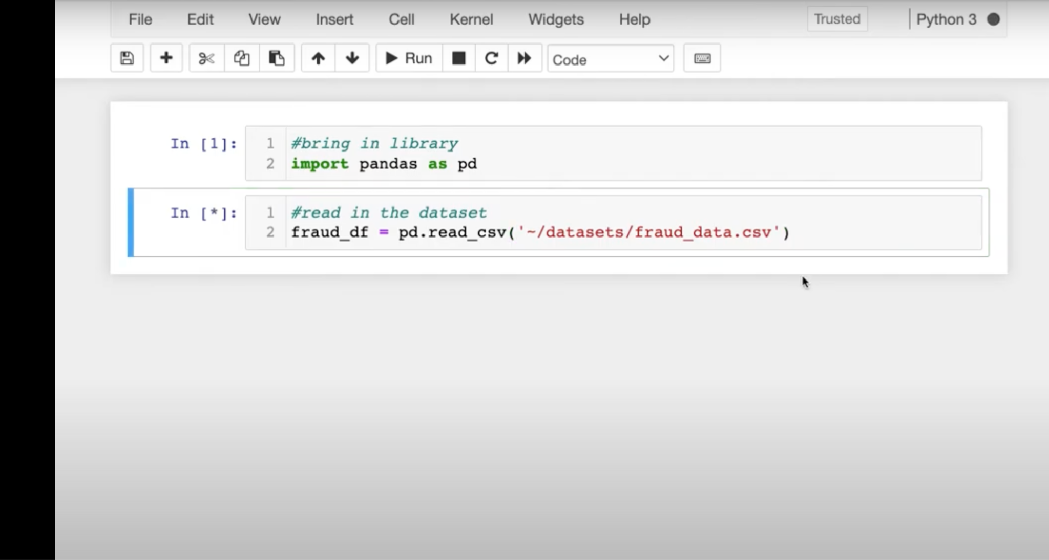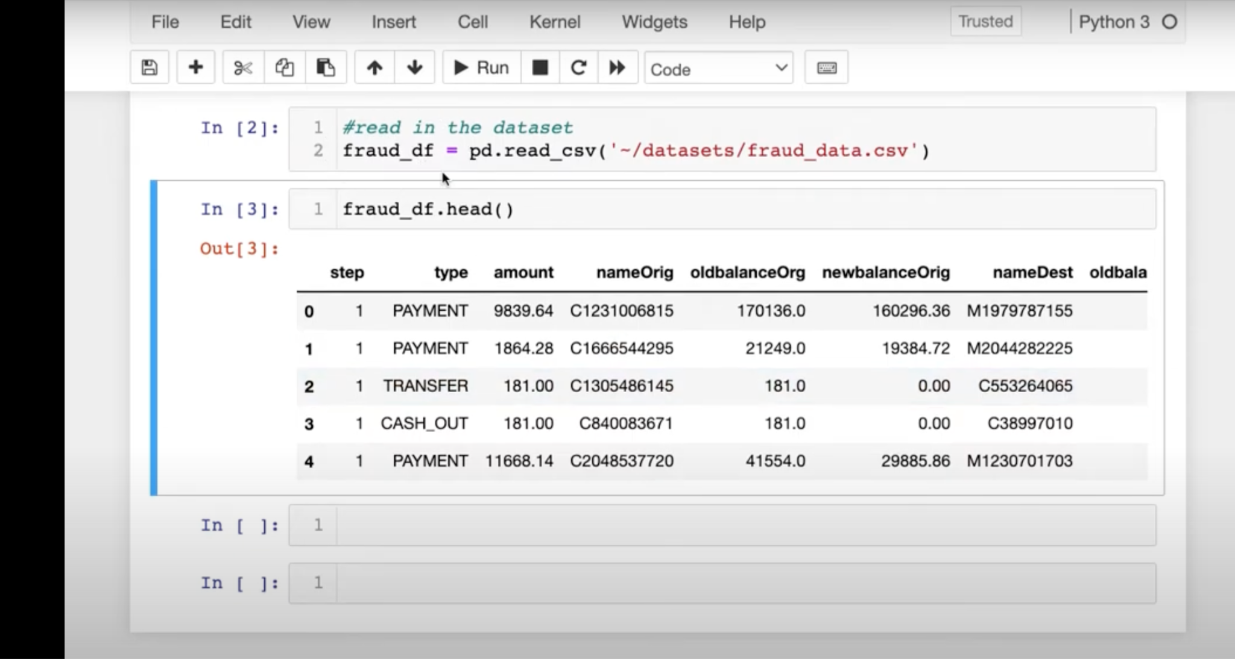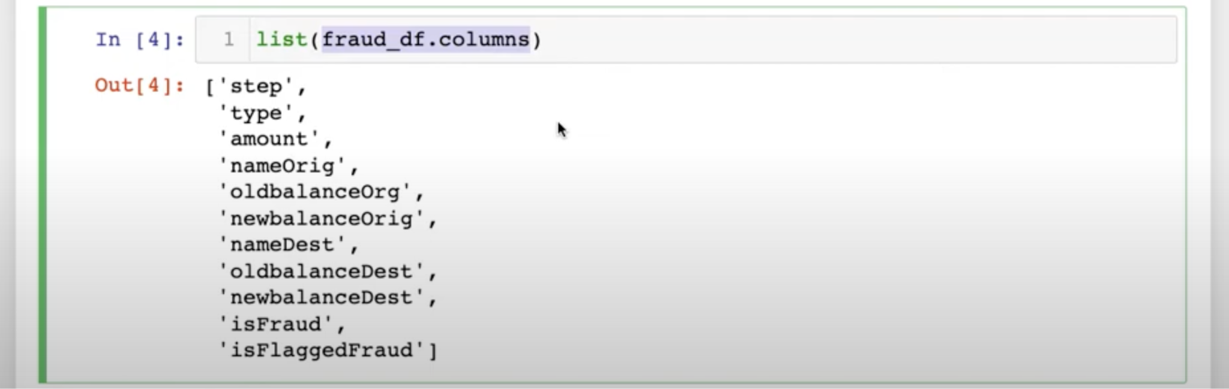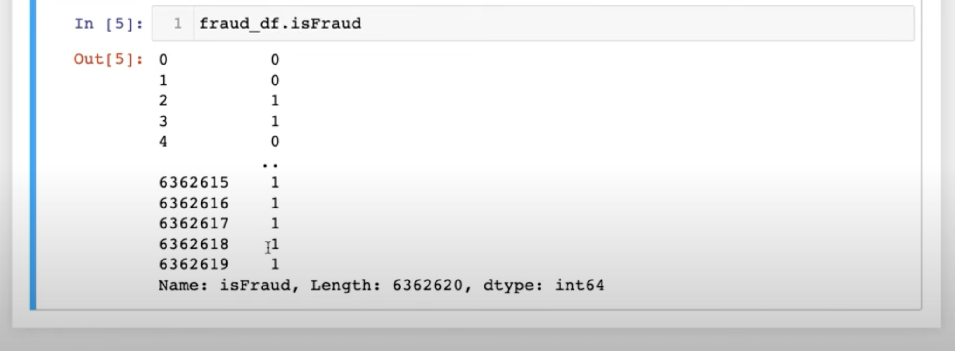
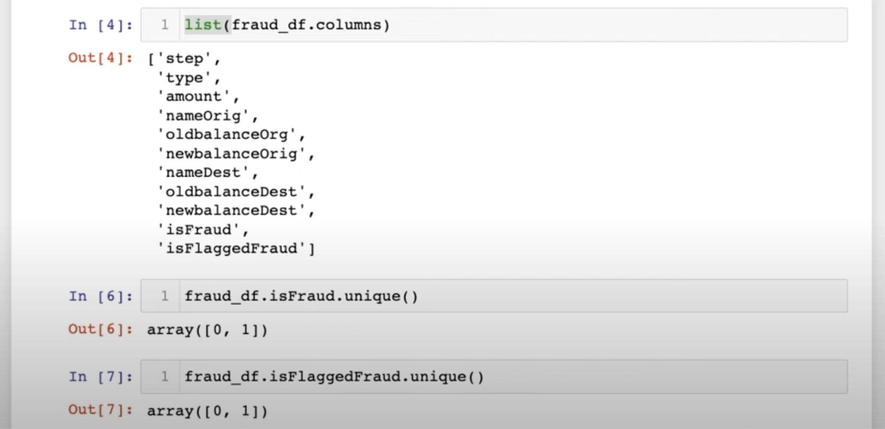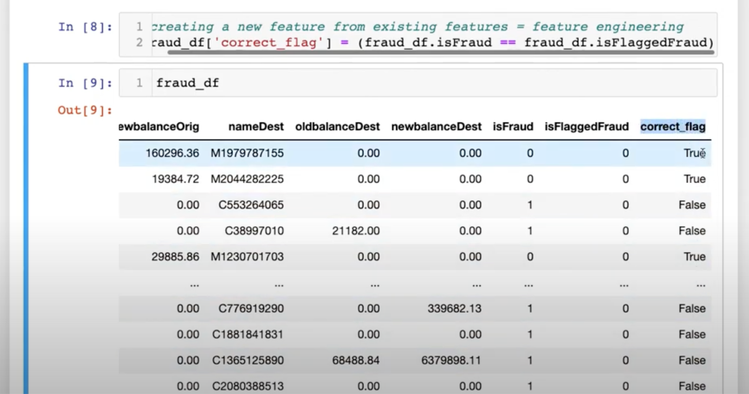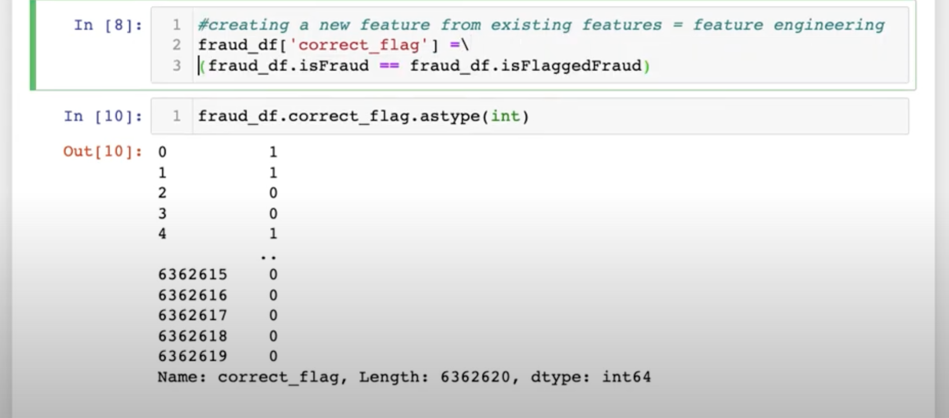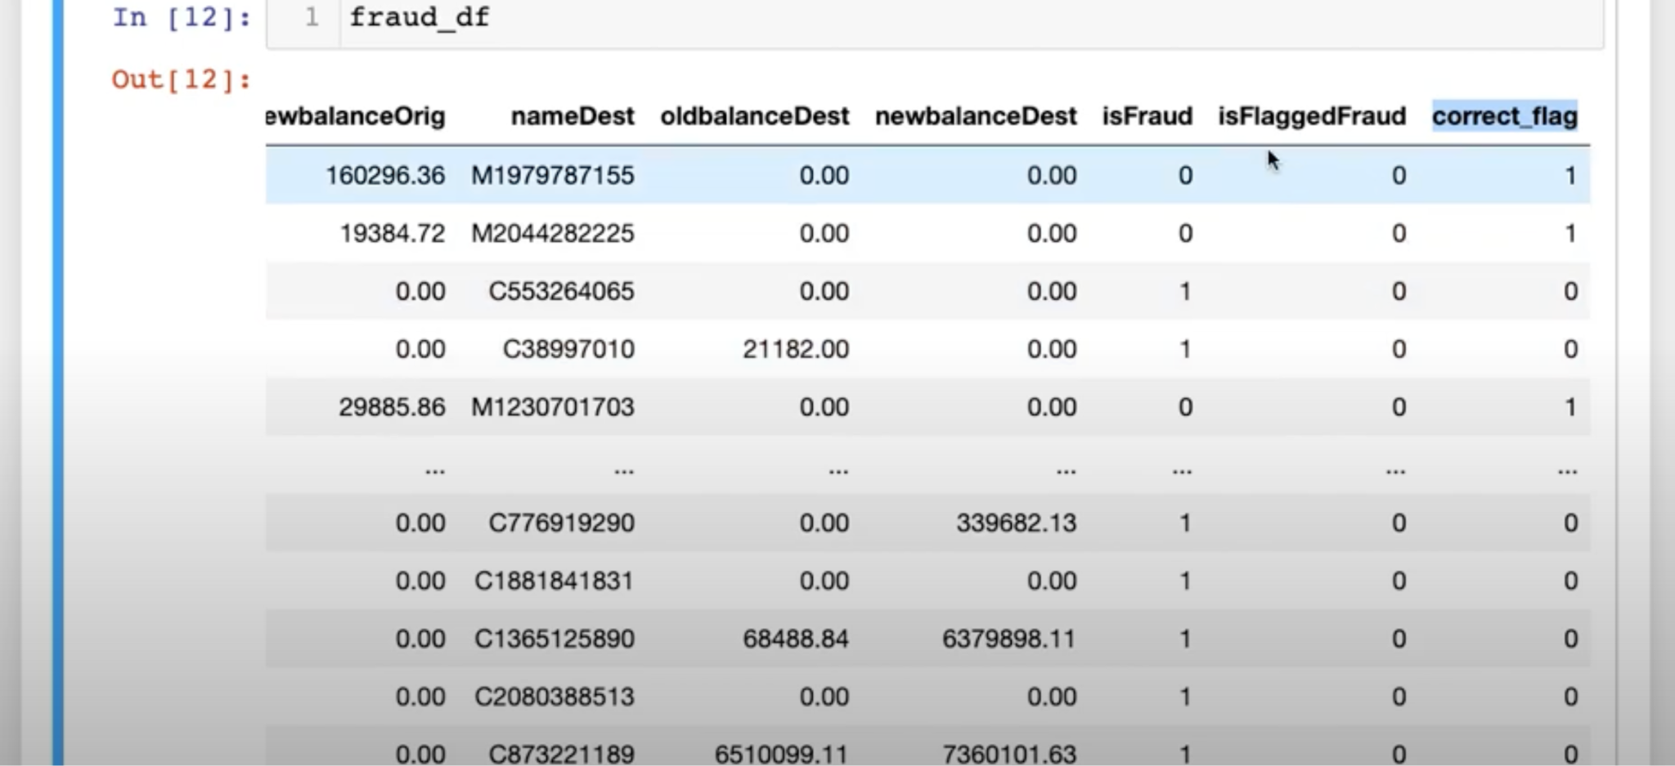

Report:
Fraud detection is a critical aspect of many businesses, and it requires real-time analysis of data to be effective. Traditional data warehouses, which are designed for batch processing and caching, are not ideal for fraud detection due to their high latency. However, operational data warehouses, which support streaming data and continuous data transformation, are well-suited for this task.
Operational data warehouses can ingest and transform data from various sources in real-time, enabling fraud detection systems to calculate fraud scores and take action while fraud is happening. This is in contrast to traditional data warehouses, which are optimized for analytics and historical reporting, and may not be able to provide real-time insights.
One example of an operational data warehouse that is used for fraud detection is Materialize. Materialize allows data teams to develop SQL logic for detecting fraud and to use this logic to detect fraud in real-time. This is made possible by Materialize support for streaming data and continuous data transformation, which enable it to process data in a continuous, incremental way and to update results as they change.
Real-time data is essential for effective fraud detection, as it allows businesses to act on fraudulent activity as it occurs. Operational data warehouses, such as Materialize, are well-suited for this task due to their support for streaming data and continuous data transformation.
In summary, operational data warehouses are a powerful tool for fraud detection, as they enable real-time analysis of data and can be used to calculate fraud scores and take action while fraud is happening. Traditional data warehouses, which are designed for batch processing and caching, are not ideal for this task due to their high latency.
___________________________________________________________________________

Outcomes:

Understanding of data warehousing and multidimensional modelling.
________________________________________________________________________

Conclusion: (Conclusion to be based on the outcomes achieved)

Operational data warehouses are a powerful tool for fraud detection, as they enable real-time analysis of data and can be used to calculate fraud scores and take action while fraud is happening. Traditional data warehouses, which are designed for batch processing and caching, may not be ideal for this task due to their high latency.
___________________________________________________________________________

Grade: AA / AB / BB / BC / CC / CD /DD

Signature of faculty in-charge with date
___________________________________________________________________________
References:

- https://www.oracle.com/in/database/what-is-a-data-warehouse
- Paulraj Ponniah, “Data Warehousing: Fundamentals for IT Professionals”, Wiley India

